**Application Load Balancer Hands-on**

**Main Tasks**

1. Create 2 ubuntu machines with Apache installed.
2. Create an Application Load Balancer.
3. Test the Load Balancer.
4. Clean up.
5. **Create 2 ubuntu instances.**
6. In AWS EC2 page, create first ubuntu instance with following settings.
   1. Give name as (First name) Ubuntu 1a.
   2. Select AMI as Ubuntu
   3. Create Key pair in case you don’t have one.
   4. In Network settings, click Allow HTTP

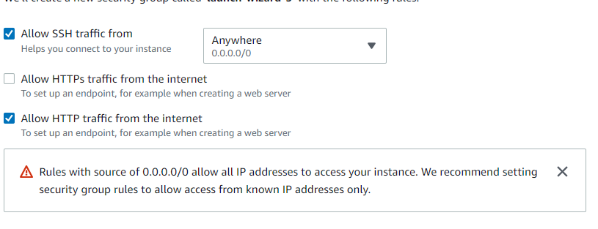

* 1. Then go up to the Network Settings section and click Edit.

* 1. In the Subnet dropdown, select subnet with Availability Zone as a

* 1. Click Launch instance.

1. Create second ubuntu instance with following settings.
   1. Give name as (First name) Ubuntu 1b.
   2. Select AMI as Ubuntu
   3. Key pair same as earlier one.
   4. In Network settings, click Allow HTTP
   5. Subnet with Availability Zone as b
2. Connect to (First name) Ubuntu 1a with Putty with (IP address, username as ubuntu and .ppk file)
3. Run the following commands to install apache2.

sudo apt update

sudo apt install apache2 -y

curl localhost:80

OR (sudo apt update && sudo apt install apache2 -y && curl localhost:80)

1. Enter the IP address of (First name) Ubuntu 1a instance in the browser of your machine to verify the Apache server is running.
2. Repeat steps d, e, and f for (First name) Ubuntu 1b instance.
3. **Create Application Load Balancer**
   1. In AWS EC2 page, left pane scroll down and click on Load Balancers. Then click on Create Load Balancer.

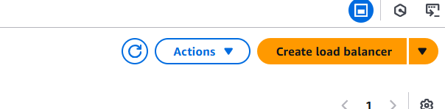



* 1. Click on Create button for Application Load Balancer.

* 1. Enter following details.
     1. Enter Name

* + 1. Under Network Mapping, select Availability Zones as a and b.

* + 1. In Security Groups, click on Create new security group.

* + 1. Enter name for security group.

* + 1. Click Add rule and Give select HTTP access for all IPs.

* + 1. Click on Create security group.

* + 1. Go back to Load Balancer tab and refresh and select the security group.

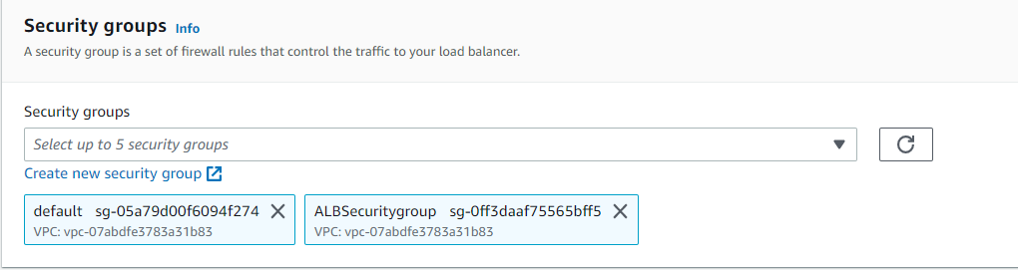

* + 1. Click on Create target group

* + 1. In the new tab, enter name and click Next

* + 1. Select both ubuntu instances and click on Include as pending below and click on Create target group.



* + 1. Go to the previous tab and refresh the target group list. Select the newly created target group.

* + 1. Click on Create load balancer.
    2. Copy the DNS name from the load balancer and paste it in browser (Only once the Status is Active).





* + 1. Once the load balancer is created, you can see the Apache home page.

1. **Test the load balancer.**
   1. Stop and start the instances and test the Load Balancing.
   2. Check the metrics in monitoring.
2. **Clean up.**
3. Delete the Load Balancer.
4. Delete the Target group.
5. Terminate the instances.